**EXPERIMENT-11**

**CREATION AND EXECUTION OF PROCEDURES**

Select * from table1;

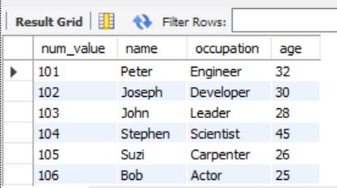

DELIMITER //

create procedure SelectAlltable1()

begin

select * from table1 where age=30;

end

DELIMITER //

create procedure Selecttable1()

begin

select * from table1;

end //

DELIMITER //

create procedure counttable1()

begin

select count(*) from table1;

end //

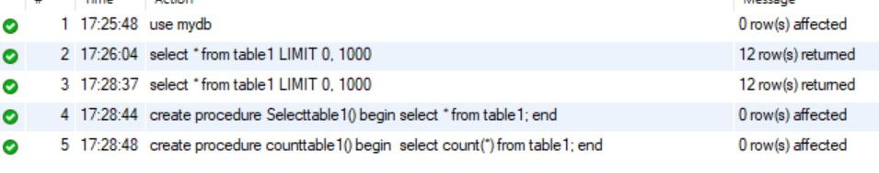

Call SelectAlltable1();

Call selecttable();

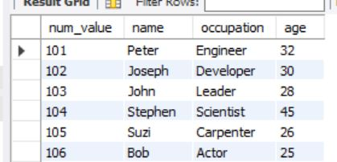

Call counttable1();

